**COMP 3710 Applied Artificial Intelligence**

**Seminar/Lab 10.**

**Uncertainty in environments, and Bayesian reasoning**

1. Objectives

* Use of joint probability distributions
* Use of conditional independence
* Use of Bayesian network
* Use of naïve Bayes classifier

1. Find the following probability from the next joint probability distribution.

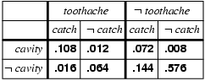

* 1. *P*(*cavity* | ~*toothache* ∨ *cavity*)

1. I'm at work, neighbor John and Mary call to say my alarm is ringing. What is the probability that the alarm is not ringing but there was earthquake? Find the probability using the next Bayesian network.

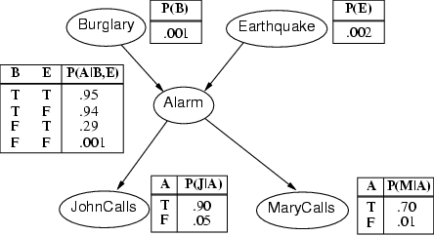

1. Consider naïve Bayes classifier with the following training data set. What is the classification for (*XLarge*, *Medium*, *Small*)?

|  |  |  |  |  |
| --- | --- | --- | --- | --- |
| *X* | *d*1 | *d*2 | *d*3 | **Class** |
| **x**1 | *Medium* | *Large* | *Medium* | *A* |
| **x**2 | *XLarge* | *Small* | *XLarge* | *B* |
| **x**3 | *Small* | *Large* | *Medium* | *A* |
| **x**4 | *Medium* | *XLarge* | *Large* | *A* |
| **x**5 | *XLarge* | *Medium* | *XLarge* | *B* |
| **x**6 | *Medium* | *Small* | *Large* | *C* |
| **x**7 | *Small* | *Medium* | *XLarge* | *A* |
| **x**8 | *Medium* | *Large* | *Large* | *B* |
| **x**9 | *Medium* | *Medium* | *XLarge* | *A* |
| **x**10 | *Large* | *Large* | *Large* | *C* |
| **x**11 | *Large* | *Medium* | *Small* | *A* |
| **x**12 | *Small* | *Medium* | *Small* | *B* |
| **x**13 | *Medium* | *Small* | *XLarge* | *A* |
| **x**14 | *XLarge* | *Large* | *XLarge* | *C* |
| **x**15 | *Medium* | *Medium* | *XLarge* | *A* |

1. After your yearly checkup, the doctor has bad news and good news. The bad news is that you tested positive for a serious disease and that the test is 99% accurate (i.e., the probability of testing positive when you do have the disease is .99,) as is the probability of testing negative when you don’t have the disease. The good news is that this is a rare disease, striking only 1 in 10,000 people of your age. What is the probability that you actually have the disease?
2. Submission
   * The title of the mail should include your name, id, and COMP 3710.

* You need to submit the assignment by email.
  + Due:
    - 11:59 pm, March 18, 2019 – with bonus 10%
    - 6:00 pm, March 20, 2019 – with the full marks
    - 6:00 pm, March 21, 2019 – with penalty 5%
    - 6:00 pm, March 22, 2019 – with penalty 10%
* Total marks: 10